**Practical No. 3**

**Aim:** Installation and Configuration of Kali/Windows OS in Virtual Box.

**Theory:**

1. **What is Kali Linux?**

[Kali Linux](https://www.kali.org/) *(formerly known as [BackTrack Linux](https://www.backtrack-linux.org/))* is an [open-source](https://www.kali.org/docs/policy/kali-linux-open-source-policy/), [Debian-based Linux](https://www.kali.org/docs/policy/kali-linux-relationship-with-debian/) distribution aimed at advanced Penetration Testing and Security Auditing. Kali Linux contains [several hundred tools](https://www.kali.org/docs/policy/penetration-testing-tools-policy/) targeted towards various information security tasks, such as Penetration Testing, Security Research, Computer Forensics and Reverse Engineering. Kali Linux is a multi-platform solution, accessible and freely available to information security professionals and hobbyists.

Kali Linux was released on the [13th March 2013](https://www.kali.org/docs/introduction/press-release/) as a complete, top-to-bottom rebuild of [BackTrack Linux](https://www.backtrack-linux.org/), adhering completely to [Debian](https://www.debian.org/) development standards.

#### **[What’s Different About Kali Linux?](https://www.kali.org/docs/introduction/should-i-use-kali-linux/" \l "whats-different-about-kali-linux)**

Kali Linux is specifically geared to meet the requirements of professional penetration testing and security auditing. To achieve this, several core changes have been implemented in Kali Linux which reflect these needs:

1. **Network services disabled by default:** Kali Linux contains systemd hooks that [disable network services](https://www.kali.org/docs/policy/kali-linux-network-service-policy/) by default. These hooks allow us to install various services on Kali Linux, while ensuring that our distribution remains secure by default, no matter what packages are installed. Additional services such as Bluetooth are also blocklisted by default.
2. **Custom Linux kernel:** Kali Linux uses an upstream kernel, patched for wireless injection.
3. **A minimal and trusted set of repositories:** given the aims and goals of Kali Linux, maintaining the integrity of the system as a whole is absolutely key. With that goal in mind, the set of upstream software sources which Kali uses is [kept to an absolute minimum](https://www.kali.org/docs/general-use/kali-linux-sources-list-repositories/). Many new Kali users are tempted to add additional repositories to their **sources.list**, but doing so runs a very serious risk of breaking your Kali Linux installation.

[Kali Linux](https://phoenixnap.com/kb/update-kali-linux) is a Debian-derived Linux distribution designed for penetration testing. With over 600 preinstalled [penetration-tes](https://phoenixnap.com/blog/best-penetration-testing-tools)[ting programs](https://phoenixnap.com/blog/best-penetration-testing-tools), it earned a reputation as one of the best-operating systems used for security testing. As a security-testing platform, it is best to install Kali as a VM on **VirtualBox.** Kali has a rolling release model, ensuring up-to-date tools on your system. Also, there is an active community of users providing ongoing support.

This step by step tutorial shows you **how to install Kali Linux on VirtualBox**.

### Step 1: Download Kali Linux ISO Image

On the [official Kali Linux website downloads](https://www.kali.org/downloads/) section, you can find Kali Linux .iso images. These images are uploaded every few months, providing the latest official releases.

Navigate to the Kali Linux Downloads page and find the packages available for download. Depending on the system you have, download the 64-Bit or 32-Bit version.

### Step 2: Create Kali Linux VirtualBox Container

Create a new virtual machine and import Kali as its OS.

1. Launch VirtualBox Manager and click the **New** icon.
2. **Name and operating system**. A pop-up window for creating a new VM appears. Specify a **name** and a **destination folder**. The Type and Version change automatically, based on the name you provide. **Make sure the information matches the package you downloaded** and click **Next**.

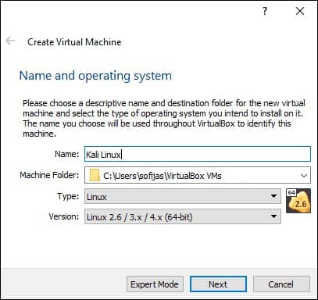

1. **Memory size**. Choose how much **memory** to allocate to the virtual machine and click **Next**. The default setting for Linux is **1024 MB**. However, this varies depending on your individual needs.
2. **Hard disk**. The default option is to **create a virtual hard disk** for the new VM. Click **Create** to continue. Alternatively, you can use an existing virtual hard disk file or decide not to add one at all.

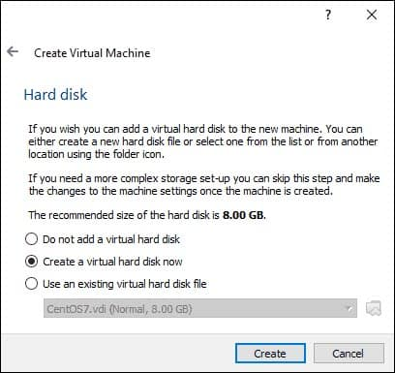

1. Hard**disk file type**. Stick to the default file type for the new virtual hard disk, **VDI** (**VirtualBox Disk Image**). Click **Next**to continue.
2. Storage**on a physical hard disk**. Decide between **Dynamically allocated** and **Fixed size**. The first choice allows the new hard disk to grow and fill up space dedicated to it. The second, fixed size, uses the maximum capacity from the start. Click **Next**.
3. File**location and size**. Specify the name and where you want to store the virtual hard disk. Choose the amount of file data the VM is allowed to store on the hard disk. We advise giving it at least **8 GB**. Click **Create**to finish.

Now you created a new VM. The VM appears on the list in the VirtualBox Manager.

### kali vm in virtualbox

**Conclusion:** Thus we have configured and installed Kali linux in Virtual box.